Assignment 2

**Use Cases**

1. Student
   * Takes notes using the canvas (To write/draw)
   * Shares notes with other students
   * Export notes to print/upload somewhere else
   * Join ‘classrooms’ for sharing
2. Teacher
   * Create, edit, manage, and delete ‘classrooms’
   * Manage ‘classroom’ notes
   * Share pre-made notes with students
3. Admin
   * Check on system integrity
   * Manage user database
   * Ban users
   * Manage notes for all users

**Screen Sketches**

*See next pages*

Screen #1 – Main Front Page (Mike, Cameron, Justin, Taylor)

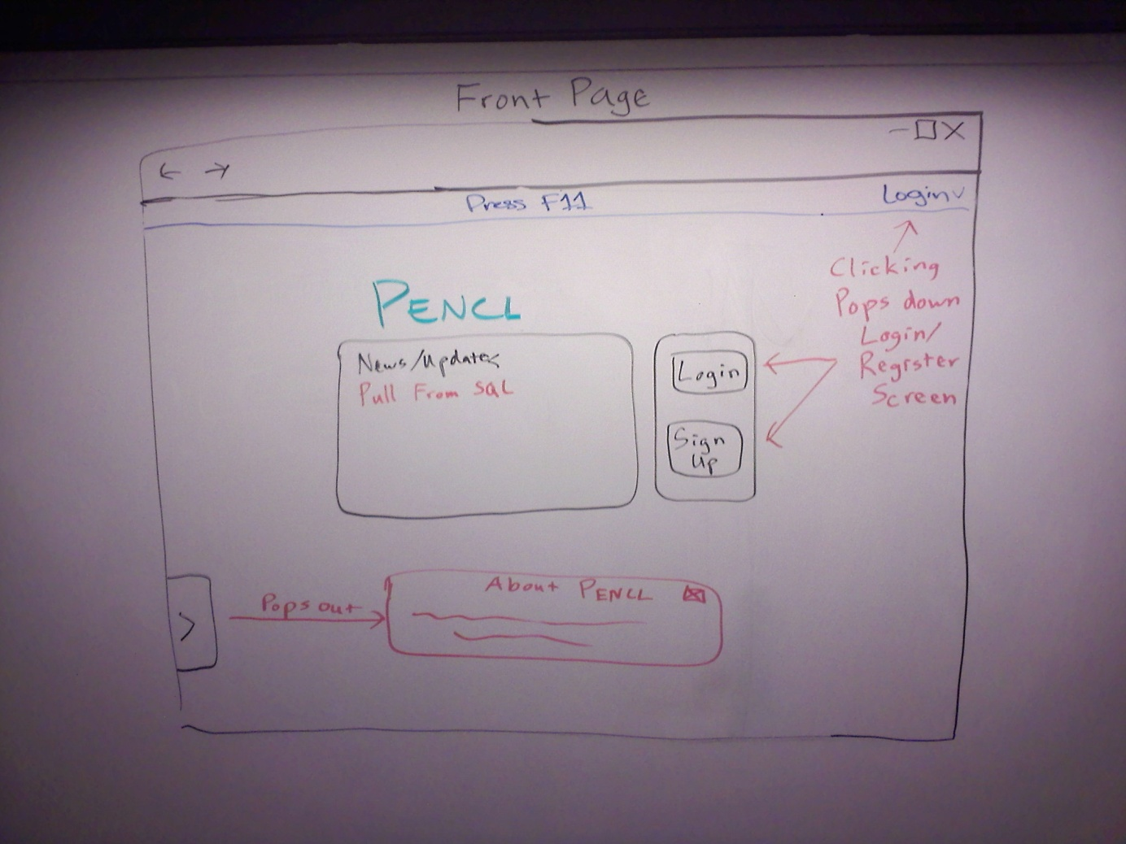

* Main page that user will be brought to when they visit the site.
* See actions in picture for events (Red text)

Screen #2 – Front Page Registering and Logging In (Mike, Cameron, Justin, Taylor)

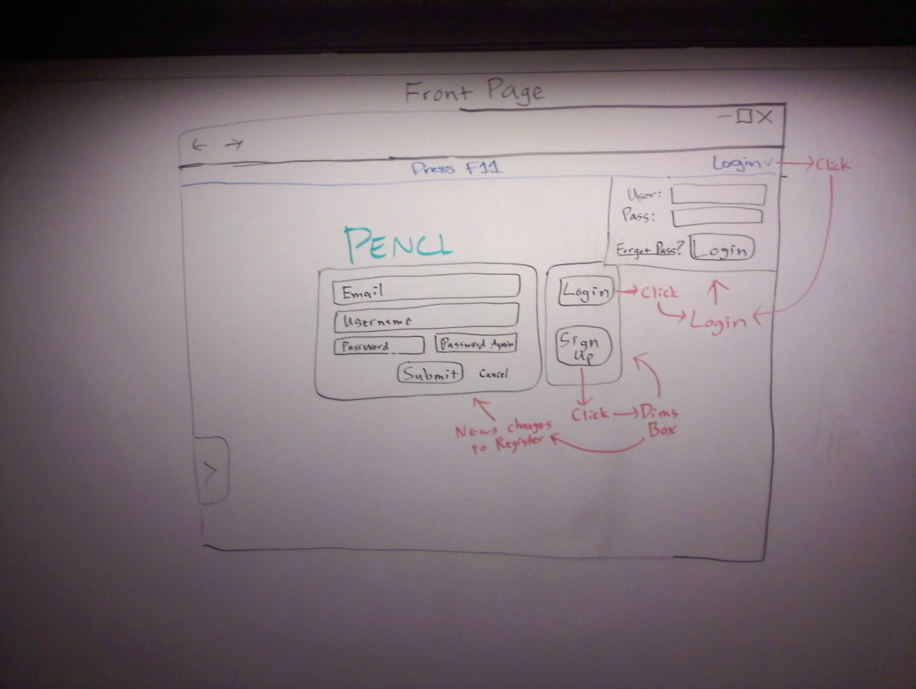

* This is the screen when the user wants to register or login to the website.
* See actions in picture for events (Red text)

Screen #3 – Registration successful (Mike, Cameron, Justin, Taylor)

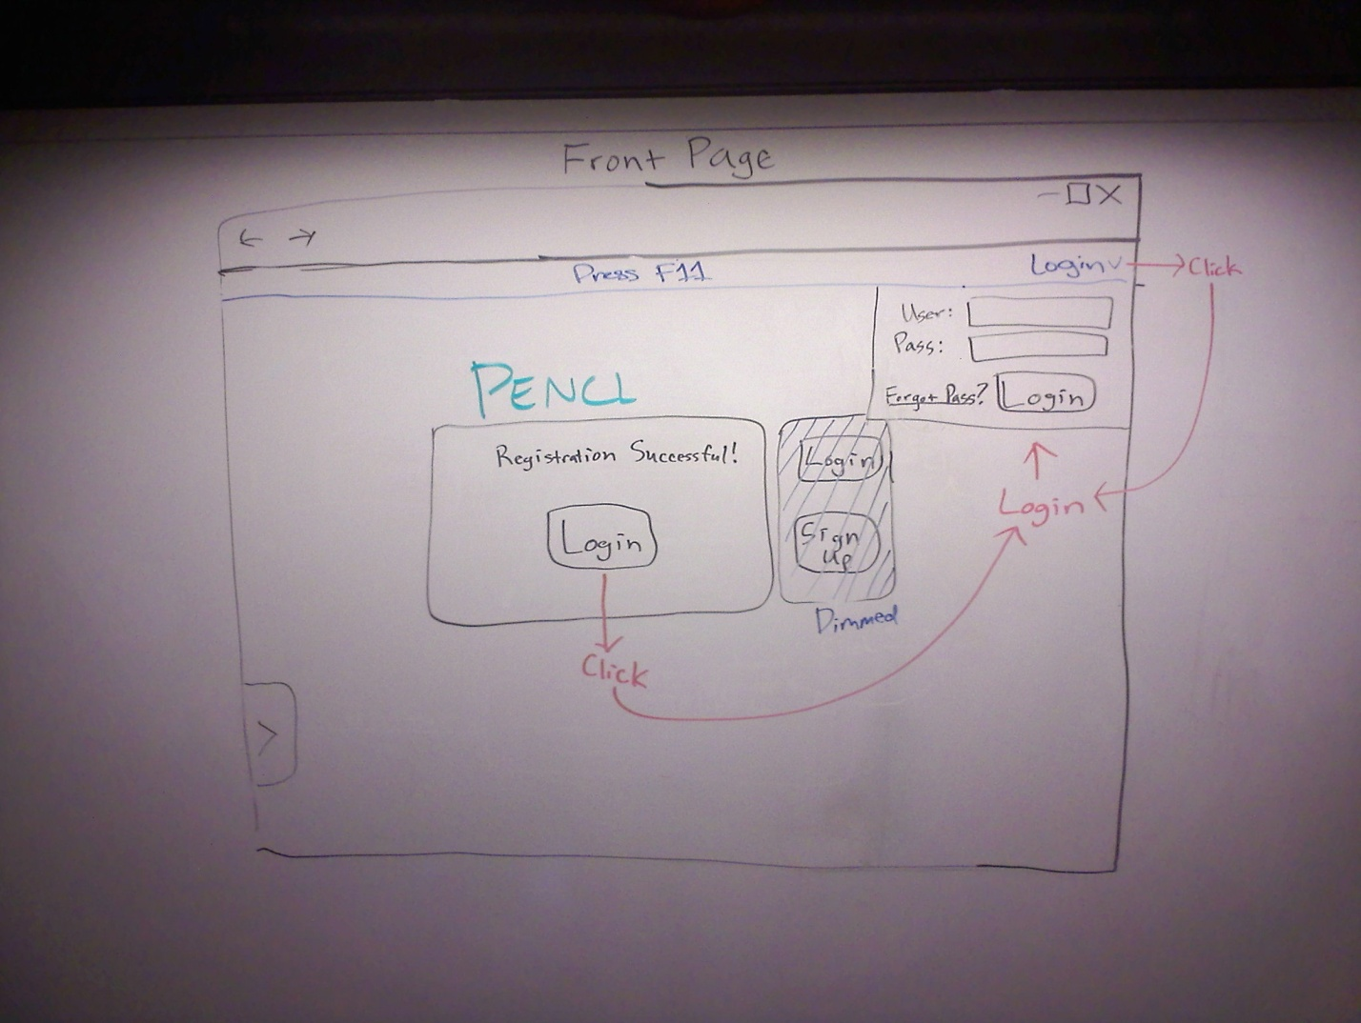

* Confirmation page when user has successfully registered.
* See actions in picture for events (Red text)

Screen #4 – Notepad Selection. With preview, deletion and addition (Mike, Cameron, Justin, Taylor)

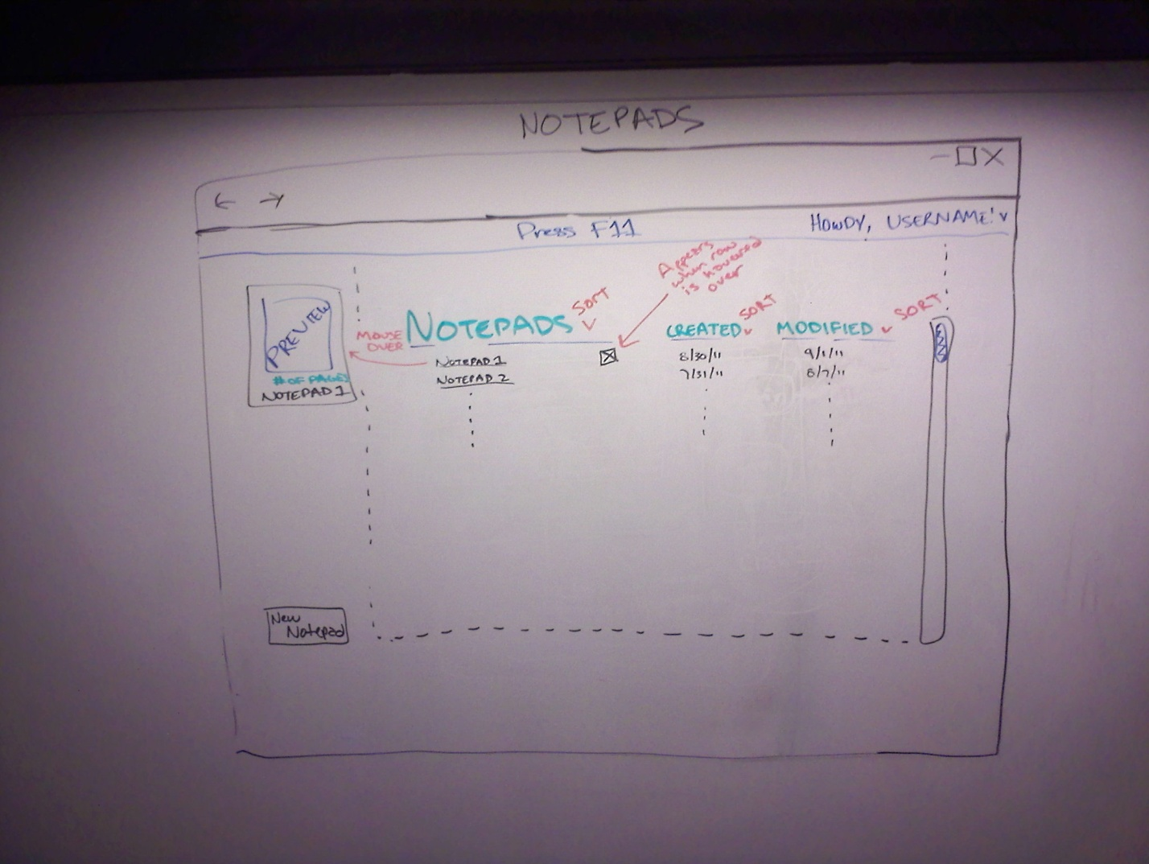

* Hovering over a notepad will bring up a preview of it for easy reference. The user can add, edit, or delete the notepad from this page.
* See actions in picture for events (Red text)

Screen #5 – Main notepad interface for entering data (Mike, Cameron, Justin, Taylor)

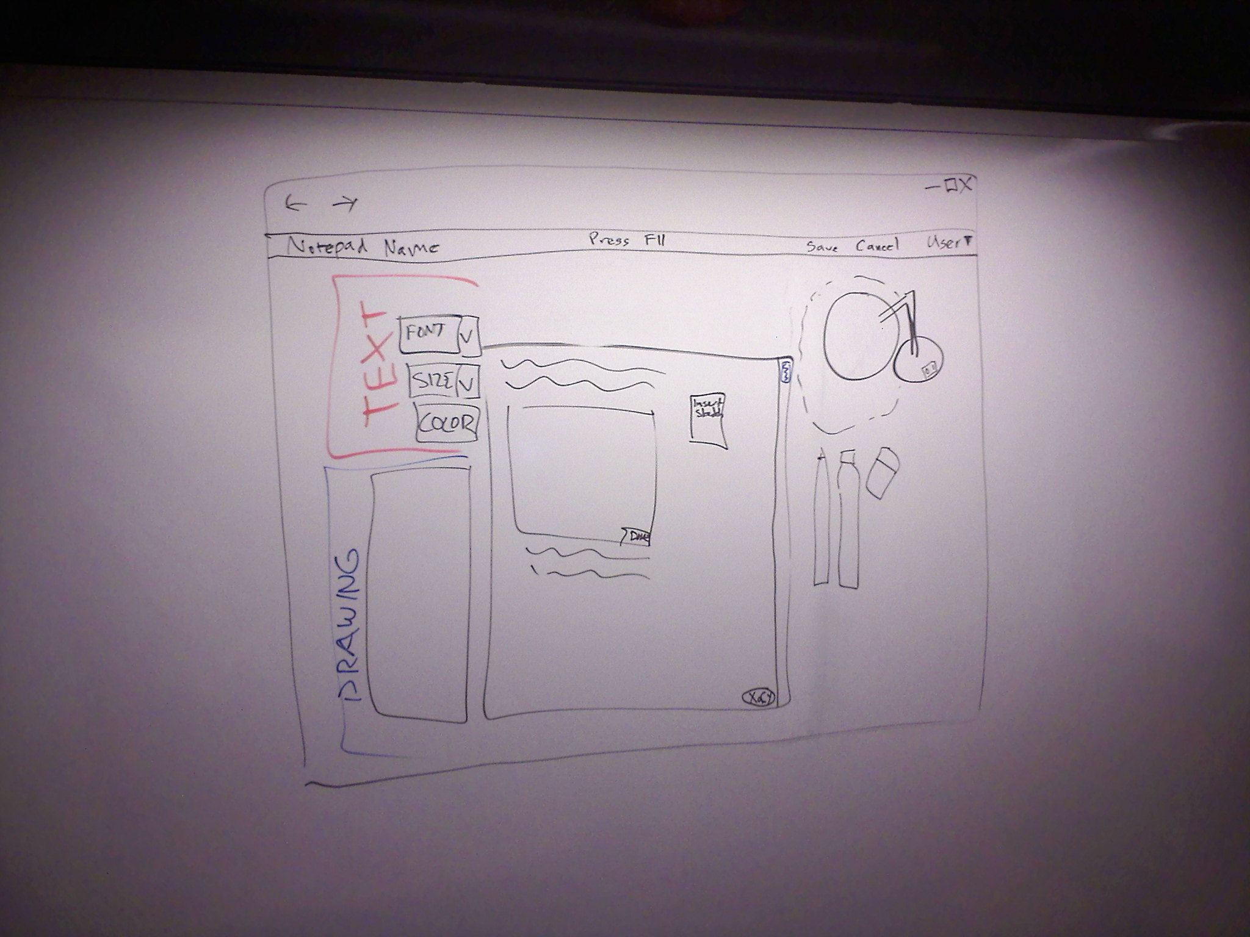

* The main editor. This will include a canvas as the main editor. The pencil, marker, and eraser are all ‘buttons’ to select what kind of drawing utensil you want to use. If you are watching a film, or need your laptop screen to be darker, you can click on the lamp to turn ‘off’ the light. Each tool populates the font, size, color selection area.
* See actions in picture for events (Red text)

**Develop Screen Flow**

* Blue arrows are actions from user (Clicking)
* Red corner boxes are buttons on the webpage
* Normal boxes are webpages (Note: The final product is aimed at 1-3 pages that hold multiple pages for seamless transitions)
* Green boxes are action details

